### Join us for a

### Grocery Tour!

Learn four key food skills:

1. Reading food labels
2. Comparing unit prices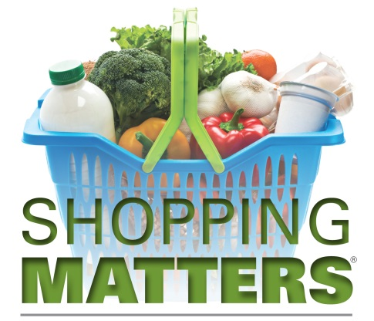
3. Finding whole grain foods
4. Identifying three ways to purchase produce

Receive a recipe book, shopping tips, and a reusable tote bag. Tours include a “Shopping Challenge “in which participants can put into practice what they learn buying healthy food for a family of four from all five food groups.

A tour and shopping challenge activity is approximately 1½ hours. Tours are conducted by UW-Extension FoodWIse Nutrition Education staff @ one of these locations:

Super One - Oakes Super One – Harborview Walmart – Superior

**For more information or to schedule a tour contact:**

[**julie.montgomery@ces.uwex.edu**](mailto:julie.montgomery@ces.uwex.edu) **or call 715-395-1427**

[**tarah.nichols@ces.uwex.edu**](mailto:tarah.nichols@ces.uwex.edu) **or call &15-395-7443**

**Free nutrition education to SNAP/FoodShare eligible Douglas County residents. 50% of FoodWIse participants must be SNAP eligible.**

An EEO/AA employer, UW-Extension provides equal opportunities in employment and programming, including Title VI, Title IX and ADA requirements. Requests for reasonable accommodations for disabilities or limitations should be made prior to the date of the program or activity for which it is needed. Please do so as early as possible prior to the program or activity so that proper arrangements can be made. Requests are kept confidential. FoodWIse is funded by the USDA Supplemental Nutrition Assistance Program - SNAP. SNAP/FoodShare helps families buy the food they need for good health. Visit access.wi.gov to learn how to apply for food assistance or call 715-395-1304.

https://lh4.googleusercontent.com/IUbBssRa5-3qpN__PFp6HZXZl2YIq3Wuh2ywKaWQ6G1uK1EOxV6Vozj3lWZtqqHaSe0fiPisrsAvkt3AIV0FWNbzv5srH66ULNhKoVhoSiHGS2Wl7op78-UQmvPkkdyAnD6U5KY